# **SQL LEFT JOIN**

**SQL LEFT JOIN:**

1. The LEFT JOIN keyword returns all records from the left table (table1), and the matching records from the right table (table2). The result is 0 records from the right side, if there is no match.
2. The syntax:

|  |
| --- |
| SELECT column_name(s)  FROM table1  LEFT JOIN table2  ON table1.column_name = table2.column_name; |

1. In some databases LEFT JOIN is called LEFT OUTER JOIN.

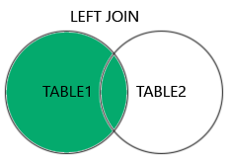

**SQL LEFT JOIN Example:**

1. The following SQL statement will select all customers, and any orders they might have:  
   Example:

|  |
| --- |
| SELECT Customers.CustomerName, Orders.OrderID  FROM Customers  LEFT JOIN Orders ON Customers.CustomerID = Orders.CustomerID  ORDER BY Customers.CustomerName; |

|  |  |
| --- | --- |
| **CustomerName** | **OrderID** |
| Alfreds Futterkiste |  |
| Ana Trujillo Emparedados y helados | 10308 |
| Antonio Moreno Taquería | 10365 |
| Around the Horn | 10383 |
| Around the Horn | 10355 |